# Chapter 7 Notes

**All Lectures Uploaded on YouTube:** [**https://tinyurl.com/fkm9-physics**](https://tinyurl.com/fkm9-physics)



## 7.1 Density

Density is defined as the mass per unit volume of a substance. It indicates how compactly the matter is packed within an object.

The substance, which has more closely packed atoms, has more matter in a fixed volume. Therefore, it is a denser substance. Solids like metals; rocks etc. are denser materials because they have closely packed atoms in the given volume. Substances in which atoms are far from each other, they have small amounts of matter in a fixed volume, so they are less dense. It is the reason why liquids and gases have less density than solids.

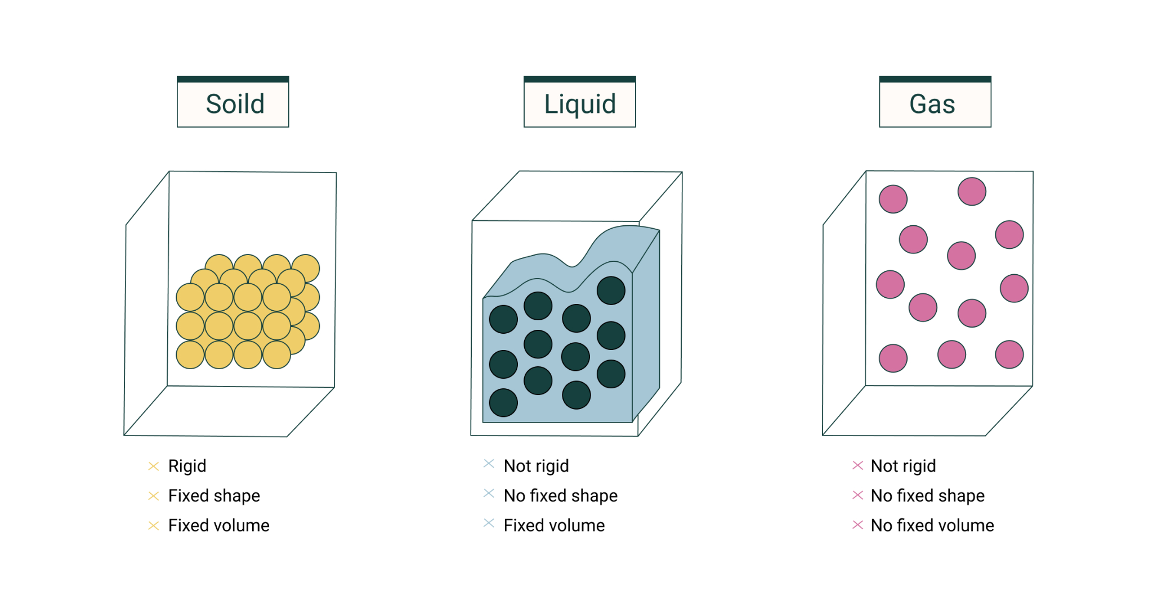

Mathematically, it is given by the formula: $ρ=\frac{m}{V}$

Where Density (ρ), Mass (m), and Volume (V)  
Units: **kg/m³** (SI unit) or **g/cm³**.

| **Densities of Different Materials** | |
| --- | --- |
| **Material** | **Density (kg/m³)** |
| Air | 1.3 |
| Pure Water | 1000 |
| Gold | 19300 |
| Iron | 7900 |
| Petrol | 800 |

## 7.2 Measuring Densities of Different Substances

To measure the densities of liquids, solids (regular shaped or irregular shape), we will follow some steps in each case:

**Density of Liquids:**

To measure the density of liquids, one measures the mass of a known volume of liquid and applies the formula $ρ=\frac{m}{V}$. Liquids can also be measured using a hydrometer which floats at a depth depending on the density.

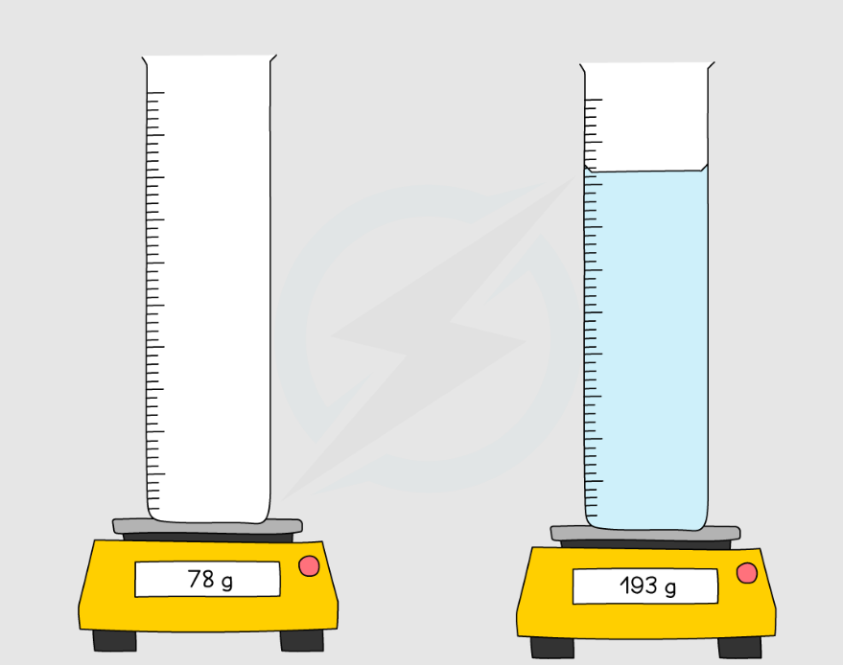

1. Place the empty measuring cylinder on balance and measure its mass.
2. Add liquid in the measuring cylinder and measure its volume.
3. Subtract mass of empty cylinder from the mass of cylinder and liquid (measured in step-2). Mass of liquid = Mass of measuring cylinder and liquid - Mass of empty cylinder
4. Measure volume of liquid from the measuring cylinder.
5. To calculate the density of liquid, divide the mass of the liquid by its volume.

$Density of liquid=\frac{Mass of Liquid}{Volume of Liquid}$

Unit: **g/mL**

### 7.2.1 Density of Regularly Shaped Solids

For regularly shaped solids such as cubes or spheres, the dimensions are measured with instruments like a ruler or Vernier calipers. The volume is calculated using geometric formulas and density is found using $ρ=\frac{m}{V}$.

To find density of regularly shaped solids, we will follow these steps:

1. Find mass of the solid regular shaped object using balance.
2. Calculate the volume of the object using formula according to the shape of the object.

$Density of Solid=\frac{Mass of Solid}{Volume of Solid}$

Unit: **kg/m³**

### 7.2.2 Density of Irregular Shaped Objects (Displacement Method)

For irregular solids, the displacement method is used. The object is submerged in water, and the displaced volume of water is equal to the volume of the object. Density is then calculated as follows:

1. Find the mass of the irregular shaped stone.
2. Add some water in the measuring cylinder and measure its initial volume.
3. Tie thread with the irregular shaped objecte.g.stone and lower it in the measuring cylinder.
4. Water will rise (i.e. displace) in the measuring cylinder and measure final volume (V). This final volume reading is the sum of volume of water and volume of object.
5. Subtract initial volume (Vi) from final volume (V,) to get volume of object. $Volume of object=V_{f}-V_{i}$
6. To find the density of objects, divide the mass of the object with its volume:

$Density of Solid=\frac{Mass of Solid}{Volume of Solid}$

Unit: **kg/m³**

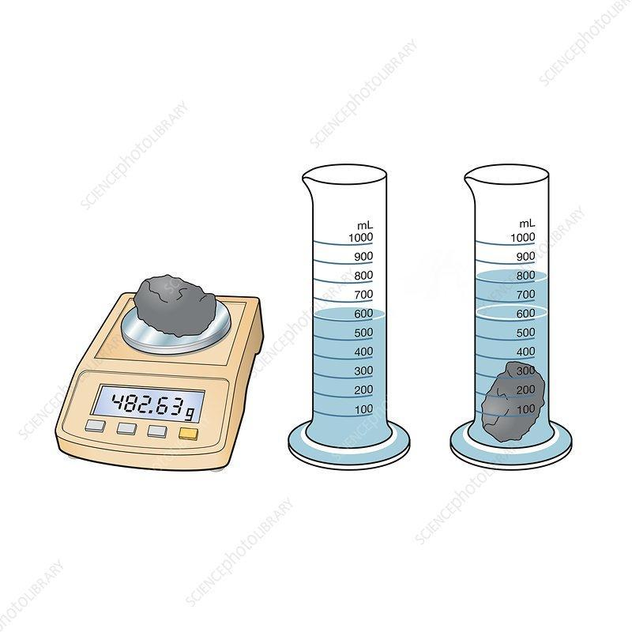

## 7.3 States of Matter

Matter exists in four fundamental states: solid, liquid, gas, and plasma. The behavior of matter depends on particle motion, density, and intermolecular forces.

* **Solids**: Have fixed shape and volume, high density, particles vibrate in fixed positions.
* **Liquids**: Have fixed volume but no fixed shape, particles slide over each other with moderate energy.
* **Gases**: Have neither fixed shape nor volume, low density, particles move freely with high energy.

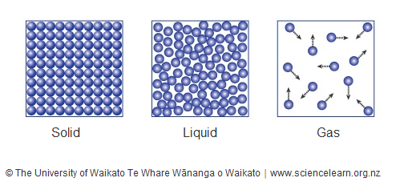

| **Properties of States of Matter** | | | | |
| --- | --- | --- | --- | --- |
| **State** | **Density** | **Arrangement** | **Movement** | **Energy** |
| Solid | High | Closely packed | Vibration only | Low |
| Liquid | Moderate | Loosely packed | Slide past each other | Moderate |
| Gas | Low | Far apart | Move freely | High |

## 7.4 Plasma as a Fourth State of Matter

Plasma is an ionized state of matter where atoms lose electrons, creating a mixture of ions and free electrons. It occurs naturally in stars, lightning, and auroras, and is used in plasma TVs and neon lights.

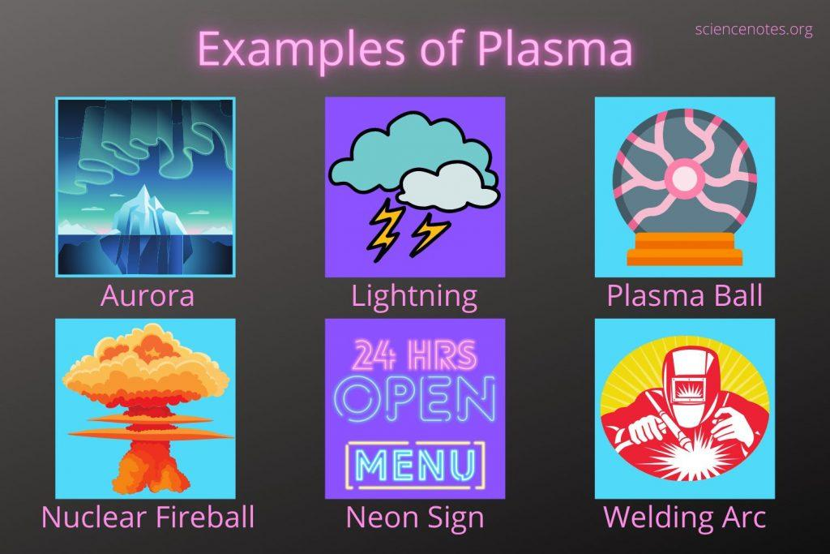

## 7.5 Relationship Between Motion of Particles and Temperature

**"The temperature of a substance is the measure of its hotness or coldness, and the temperature of a substance is directly proportional to the average K.E.of its particles."**

The motion of particles increases with temperature as their kinetic energy increases. At absolute zero **(0 K or -273°C)**, the kinetic energy of particles becomes zero. Graphs of kinetic energy vs temperature show linear relationships in both Kelvin and Celsius scales.

**"Absolute zero is the lowest possible temperature of a substance at which its particles have least kinetic energy"**

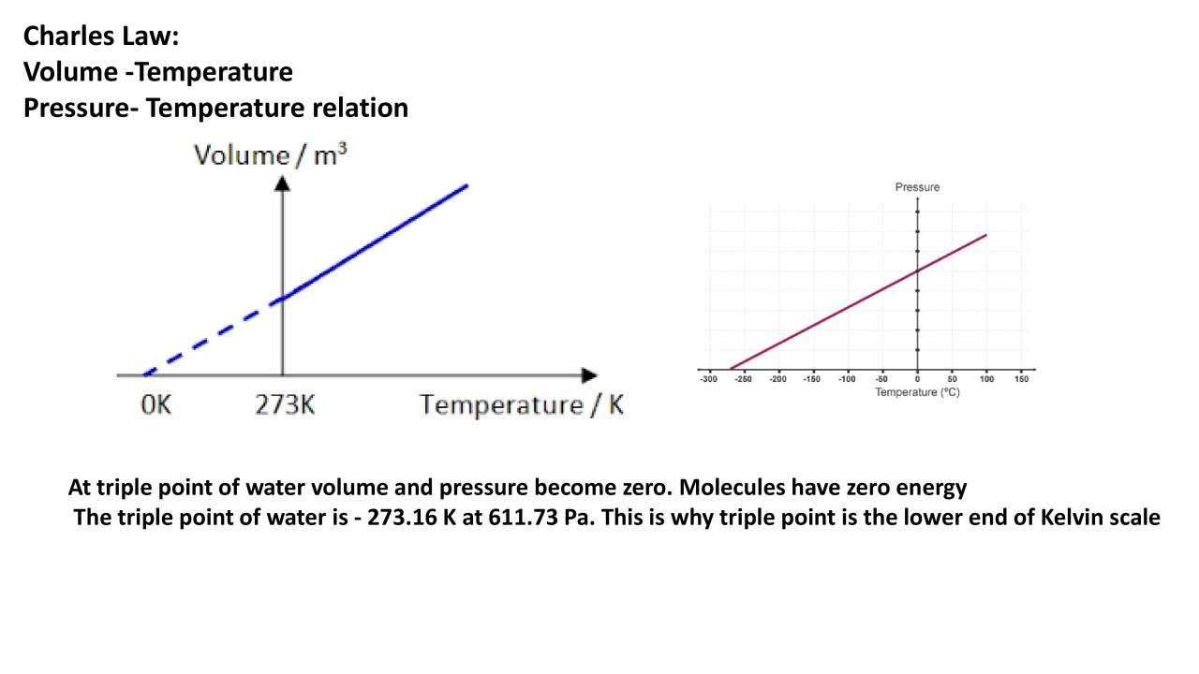

Its value is zero kelvin (0K) while on the Celsius scale, it is -273.15°C. At absolute zero, there is no heat energy available to move the particles of the substance.

## 7.6 Internal Energy and Temperature of a Substance

The internal energy of a substance is the total of kinetic energy (due to motion of particles) and potential energy (due to intermolecular forces). Temperature measures the average kinetic energy of particles.

These particles can have three forms of kinetic energies i.e. translational K.E., rotational K.E. and vibrational K.E. In the case of ideal gas, it has only translational kinetic energy of particles. Therefore, its internal energy is only due to the kinetic energy of particles.

## 7.8 Variation in Physical Properties as a Tool for Measuring Temperature

Several physical properties of substances vary with temperature and can be used to measure temperature.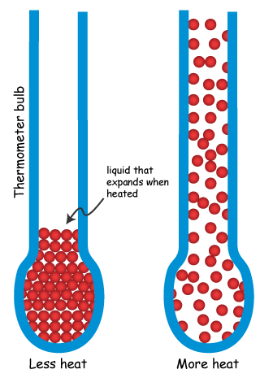

### 7.8.1 Expansion of Liquids

Liquids expand when heated. This property is used in liquid-in-glass thermometers.

Most liquids expand upon heating. Liquids that expand on heating uniformly can be used as thermometric materials. We use this property for liquids in glass thermometres, which use mercury or alcohol as thermometric materials. When this thermometer is touched by a hot body, it absorbs heat from the body and causes the mercury to expand. This uniform expansion of mercury varies linearly with temperature when absorbing heat.

### 7.8.2 Variation of Volume and Pressure

In gases, both volume and pressure vary with temperature. This principle is used in gas thermometers.

A constant volume gas thermometer uses the principle that the pressure of a gas is directly proportional to the temperature, while the volume of the gas is kept constant (Gay-Lussac's law).

### 7.8.3 Variation in Colour of Crystals

Some crystals change color with temperature. These are used in temperature-sensitive strips.

Liquid crystals are substances that change colour with a change in temperature. In these thermometers, a liquid crystal material is sealed in a plastic strip or patch. We touch it with the body whose temperature is to be measured. When its temperature changes, it also changes colour.

### 7.8.4 Resistance Thermometers or Thermistors

Resistance of metals and semiconductors changes with temperature, used in electronic thermometers.

### 7.8.5 Bimetallic Strip Thermometers

Made of two metals with different expansion rates, causing bending with temperature change. Commonly used in thermostats.

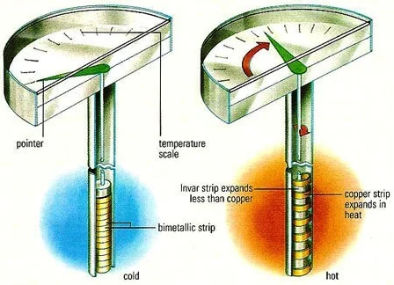

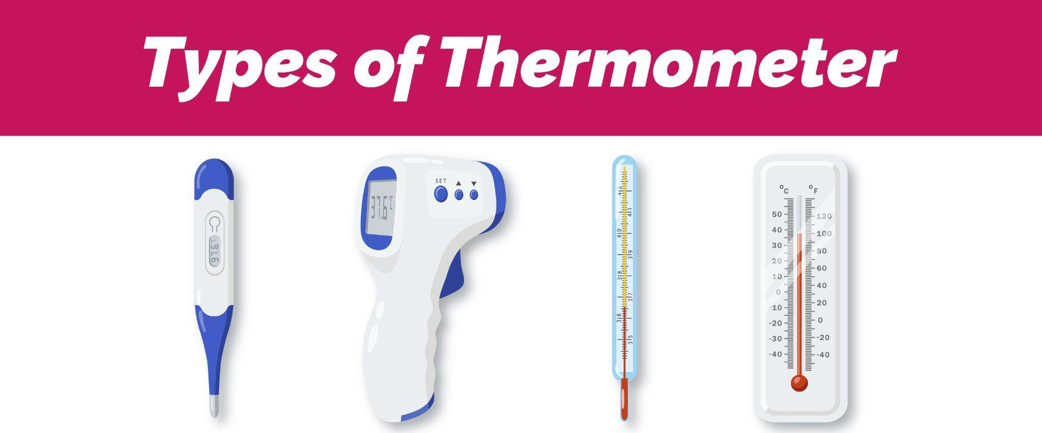

## 7.9 Fixed Points in Calibration of Thermometers

When a thermometer is used to determine the temperature of a body, we measure its reading from the calibrated scale made on it. Without a temperature scale, a thermometer is valueless.

Fixed points are reference temperatures used to calibrate thermometers, such as the melting point of ice (0°C) and boiling point of water (100°C).

## 7.10 Sensitivity, Range and Linearity of Thermometers

### 7.10.1 Sensitivity

Sensitivity refers to the thermometer’s ability to detect small temperature changes. We can say that it is the smallest variation in temperature which a thermometer can measure.

Mercury thermometre is a sensitive thermometre. To illustrate sensitivity of a thermometre, place it in a glass of water at room temperature and let it to set at room temperature. Then, add a few drops of hot water to the glass. We will see that mercury in the thermometer will rise quickly to show a change in temperature of water. 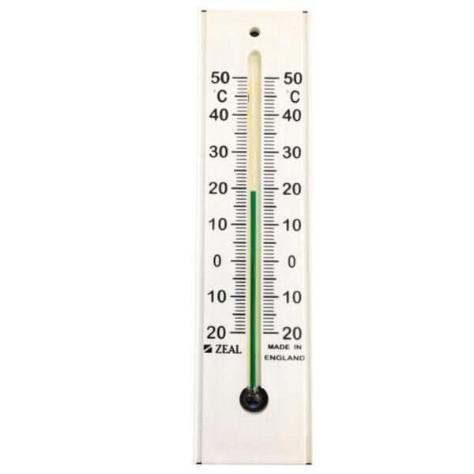

### 7.10.2 Range

Range is the span of temperatures a thermometer can measure, from its minimum to maximum reading.

### 7.10.3 Linearity

Linearity means the thermometer gives equal changes in readings for equal temperature changes. Thermometres scales have equally spaced marks on its scale.

## 7.11 Structures and Functions of Thermometers

### 7.11.1 Liquid-in-Glass Thermometers

A glass thermometer usually has a long, thin glass tube with a bulb at the end. The bulb contains mercury or alcohol as a liquid. The liquid expands as it warms and contracts as it cools.

Reading of temperature on the thermometre scale is measured. The scale is calibrated so that a certain temperature is represented by the height or position of the liquid inside the thermometer tube.

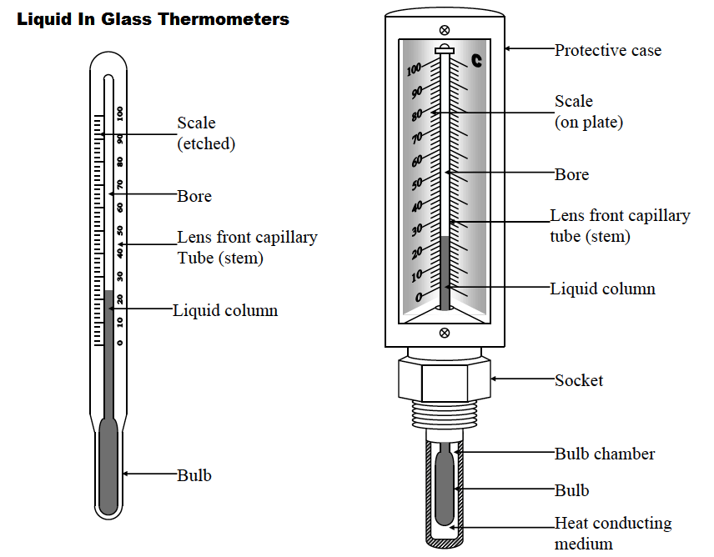

### 7.11.2 Thermocouple Thermometers

Made of two different metals joined together. A voltage is produced at the junction depending on temperature, useful for high-temperature measurements.

Thermocouple thermometers have two wires made of different metals that are joined at one end. This junction is called the hot junction. The other ends of the wires, called the coldjunctions, are connected toa measuring device,such as a voltmeter.

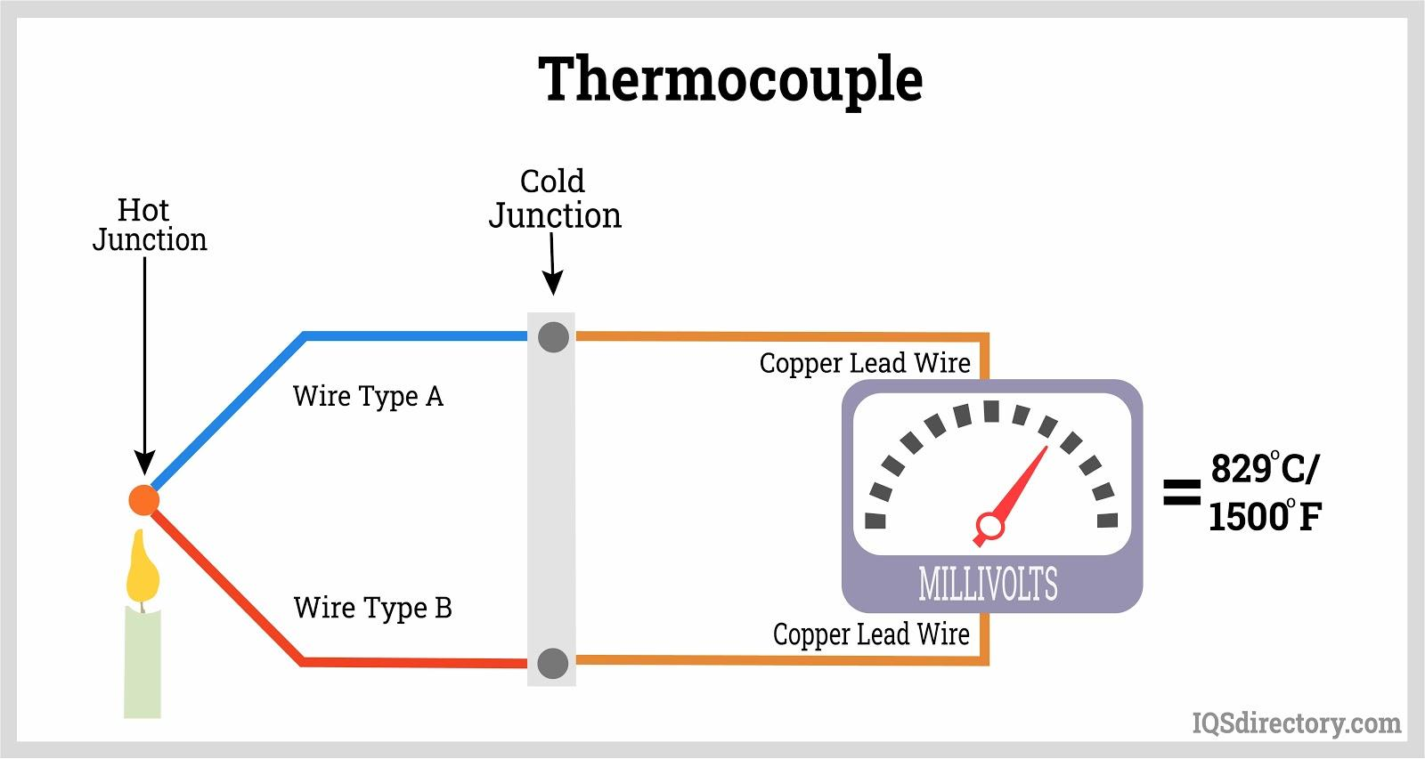

## 7.12 Effect of Structure of a Liquid-in-Glass Thermometer on its Sensitivity, Range and Linearity

### 7.12.1 Effect of Diameter of Tube

Smaller tube diameter increases sensitivity as small expansions cause noticeable rises in liquid level.

### 7.12.2 Effect of Nature of Liquid on Sensitivity

Liquids with higher expansion coefficients like alcohol make the thermometer more sensitive.

### 7.12.3 Effect of Size of Bulb on Range

Larger bulbs hold more liquid, affecting the thermometer’s range and responsiveness.

### 7.12.4 Effect of Nature of Liquid on Range

Liquids with higher boiling points, like mercury, extend the thermometer’s range compared to alcohol.

### 7.12.5 Effect of Type of Glass on Linearity

The thermal expansion of glass affects linearity; specially treated glass improves thermometer performance.

